Ideation Phase
Brainstorm & Idea Prioritization Template

Date | 20 February 2026
Team ID | LTVIP2026TMIDS79258
Project Name | Gemini Historical Artifact
Maximum Marks | 4 Marks

Brainstorm & Idea Prioritization:
Brainstorming is a structured creative process that allows team members to freely share ideas and explore innovative solutions for identified problems. It encourages open discussion, collaboration, and critical thinking among participants to generate multiple possible approaches without immediate judgment. This method helps in identifying practical and impactful solutions by focusing first on idea generation and then on evaluation.
In the Gemini Historical Artifact project, brainstorming played a crucial role in identifying the most suitable application of generative AI within the historical and educational domain. The team explored various concepts such as AI-based chatbots, virtual museum assistants, timeline generators, and automated documentation systems. Each idea was analyzed based on feasibility, innovation, implementation time, and real-world usefulness.
Through idea grouping and prioritization, the team selected the development of an AI-powered historical artifact description generator. This solution was chosen because it effectively addresses the problem of time-consuming manual research and content preparation while being technically feasible within the project scope. The final idea demonstrates a balance between creativity, practicality, and technological relevance, ensuring that the developed system delivers meaningful value to users.

Step-1: Team Gathering, Collaboration and Select the Problem Statement
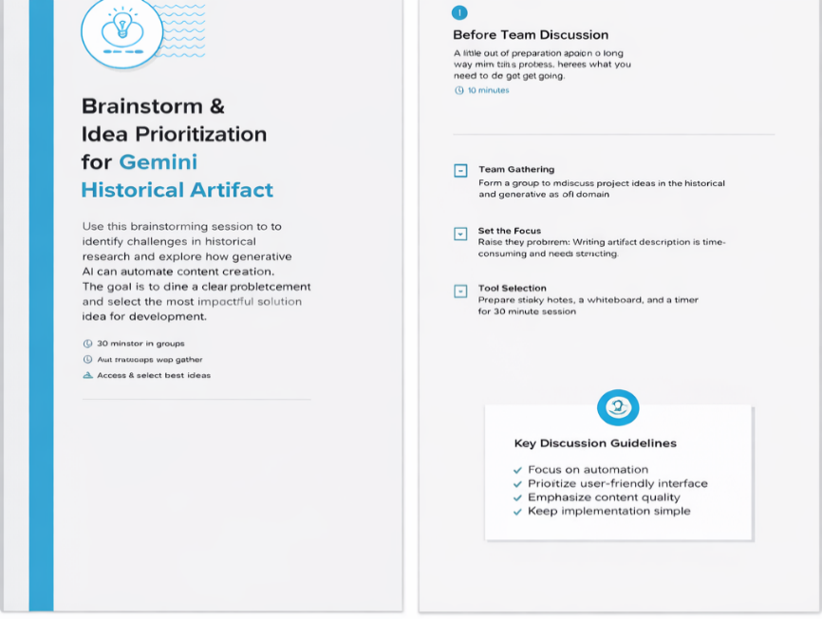
Step-2: Brainstorm, Idea Listing and Grouping and Idea Prioritization

